PROJECT ON

INSURANCE MANAGEMENT SYSTEM

for the partial completion of 10+2 H.P. Board Practical.

Submitted By: Submitted To:
Priya Vashishth Kullu Valley Sr. Sec. School
10+2 (Non Medical)

Project Guide
Mr. Angil Kumar
(Lecturer in I.P.)

S. NO. | STUFFING | PAGE NO.
1.  2.  3.  (i)  (ii)  4.  5.  6.  7. | Acknowledgement  Certificate  Working Environment  - Introduction to front end (Visual Basic)  - Introduction to back end (Oracle)  Prologue to the project  Coding  Conclusion  Bibliography | 1  2  3  14  15

No task is a single man’s effort. Various factors, situations and persons integrate together to provide the background for accomplishing a task. This project report can never be called a single man’s effort because the might and potency of many a man lies here unfolded in front of all.

I am really privileged and conceited to express my gratitude to everyone who has helped and supported me to bring out all my knowledge in this report and also to have an ultimate touch added to my understanding while completing this assignment. I shall always be very grateful to every single person who was with me while completing this task.

I would also like to thank Angil Sir for providing us with every sort of help and comfort in having more knowledge about each and every thing about our subject and even more than that. We could never ever have had more knowledge than what we gained here.

Insurance is the equitable transfer of the risk of a loss, from one entity to another in exchange for payment. It is a form of risk management primarily used to hedge against the risk of a contingent, uncertain loss.
An insurer, or insurance carrier, is a company selling the insurance; the insured, or policyholder, is the person or entity buying the insurance policy. The amount to be charged for a certain amount of insurance coverage is called the premium. Risk management, the practice of appraising and controlling risk, has evolved as a discrete field of study and practice.
The transaction involves the insured assuming a guaranteed and known relatively small loss in the form of payment to the insurer in exchange for the insurer's promise to compensate (indemnify) the insured in the case of a financial (personal) loss. The insured receives a contract, called the insurance policy, which details the conditions and circumstances under which the insured will be financially compensated.
The Max Life Insurance (MLI) is one of the largest mutual life-insurance companies in the United States, and one of the largest life insurers in the world, with about $287 billion in total assets under management. Max Life Insurance Company Ltd is a joint venture between Max India Ltd., one of India’s multi-business corporations and M S Group Japan, a Fortune 100 company. Incorporated in 2012, Max Life started commercial operation in 2001 and today is one of India’s leading private life insurance companies. The company offers individual and group life insurance products and is present across the country through a wide distribution network of multi channel distribution.

CODING…

Login Form Coding
Option Explicit
Public LoginSucceeded As Boolean

Private Sub cmdCancel_Click()
LoginSucceeded = False
Me.Hide
End Sub

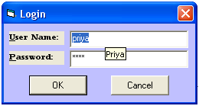

Private Sub cmdOK_Click()
If txtPassword = "fate" And txtUserName = "priya" Then
LoginSucceeded = True
Me.Hide
frmSplash.Show
MsgBox "Login Succeeded... :)"
Else
MsgBox "Invalid Password, try again!", , "Login"
txtPassword.SetFocus
SendKeys "{Home}+{End}"
End If
End Sub

Private Sub Form_Load()
txtUserName.ToolTipText = "Priya"
End Sub

Splash Screen Coding
Option Explicit

Private Sub Form_KeyPress(KeyAscii As Integer)
Unload Me
End Sub

Private Sub Form_Load()
lblVersion.Caption = "Version " & App.Major & "." & App.Minor & "." & App.Revision
lblProductName.Caption = App.Title
End Sub

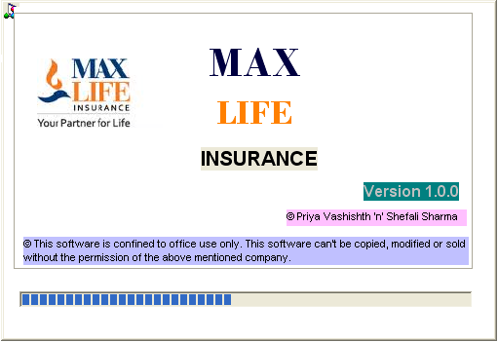

Private Sub Frame1_Click()
Unload Me
End Sub

Private Sub Timer1_Timer()
If ProgBar.Value < 99 Then
ProgBar.Value = ProgBar.Value + 1
Else
MDIForm1.Show
End If
End Sub

MDI Form Coding
Private Sub mnuNM_Click()
frmAppForm.Show
End Sub



‘FRMVIEWDETAILS’
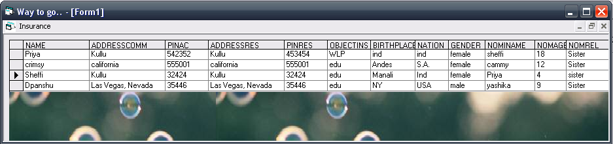

Private Sub mnuv_Click()
Form1.Show
End Sub

APPLICATION FORM CODING

Private Sub Form_Load()
AdoAgent.Refresh
AdoCustomer.Refresh
AdoAgent.Recordset.AddNew
AdoCustomer.Recordset.AddNew
End Sub

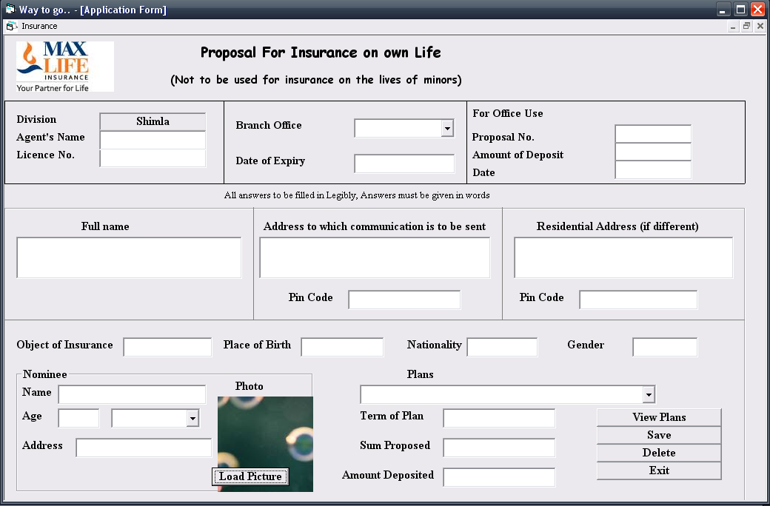

Private Sub Text15_GotFocus()
If TxtResAddress.Text = "" And TxtPinResComm.Text = "" Then
TxtResAddress.Text = TxtResComm.Text
TxtPinResComm.Text = TxtPinRes.Text
End If
End Sub

Private Sub CmdViewFrmPlans_Click()
CmdViewFrmPlans.ToolTipText = "View the Plans available"
FrmPlans.Show
Unload FrmAppForm
End Sub

Private Sub CmdSave_Click()
AdoAgent.Recordset.Update
AdoCustomer.Recordset.Update
End Sub

Private Sub CmdNomPhoto_Click()
cd.ShowOpen
NomineePic.Picture= LoadPicture(cd.FileName)
End Sub

Private Sub CmdDelete_Click()
AdoAgent.Recordset.Delete
End Sub

‘VIEW FRMPLANS’ FORM CODING
Public PlanName As String
Private Sub cmdConfirmPlan_Click()
a =lblPlanName.Caption
End Sub

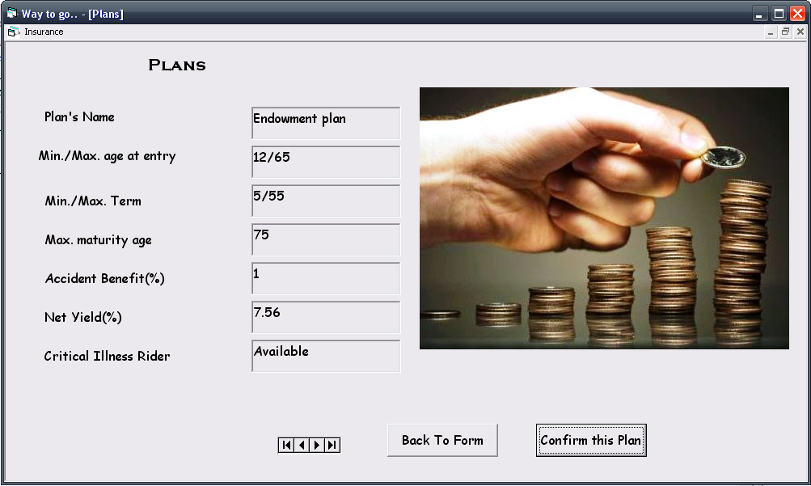

Private Sub cmdBack_Click()
frmAppForm.Show
Unload frmPlans
frmAppForm.frmPlans.Text = a
End Sub

S. No. | Stuffing | Sources/Authors
1. | Introduction to Insurance | wikipedia.com
2. | Insurance Management | google.com
3. | Max Life Insurance | maxinsurance.org
4. | Additional Information | Dinesh Pub. XII I.P.

